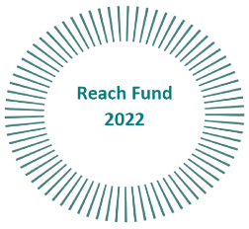
UNITY IN DIVERSITY
Expression of interest form
Name and Surname
Postal address
Contact number
Email address
Do we have the consent to use your picture?  Please circle YES or NO | YES | NO
Do we have the consent to contact you?  Please circle YES or NO | YES | NO

Please note only one course can be allocated per participant.
NB: Course places will be allocated in line with funding priorities

